Property Registration UI

Tool used: FileMaker

Prepared by Virginia Ip n8810532

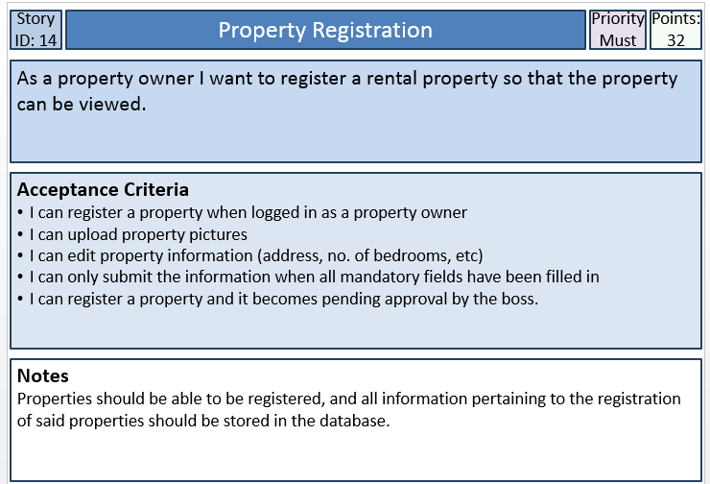

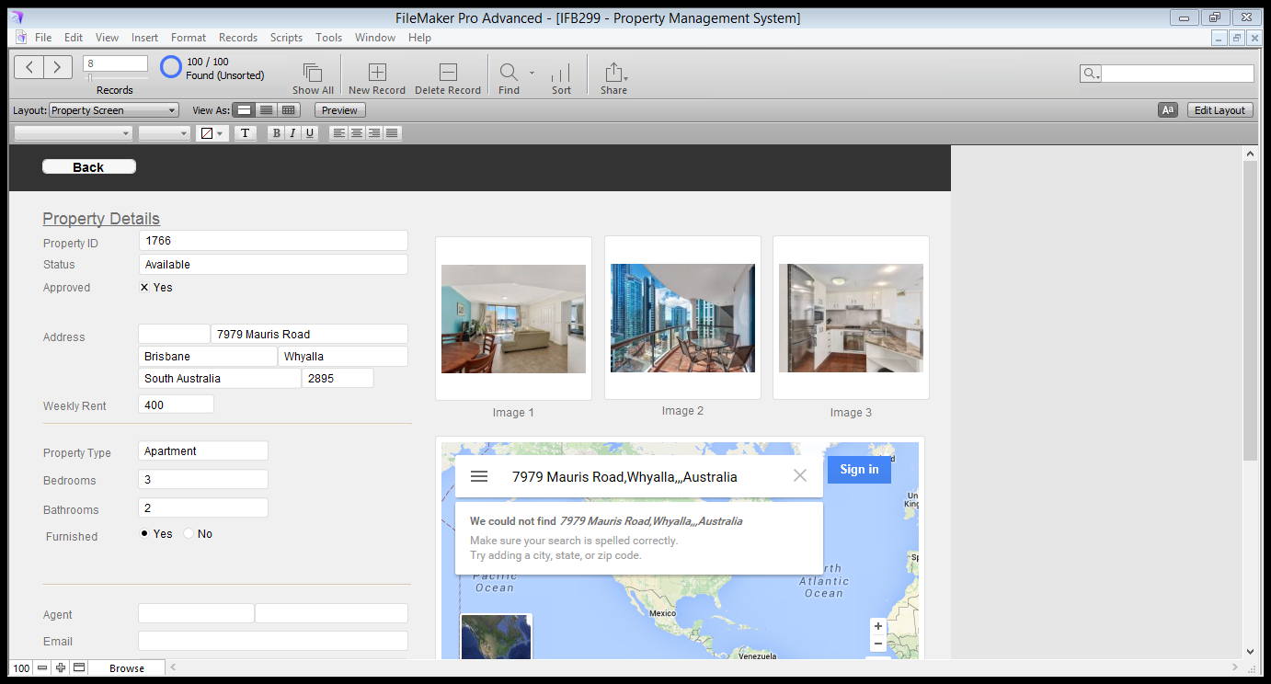

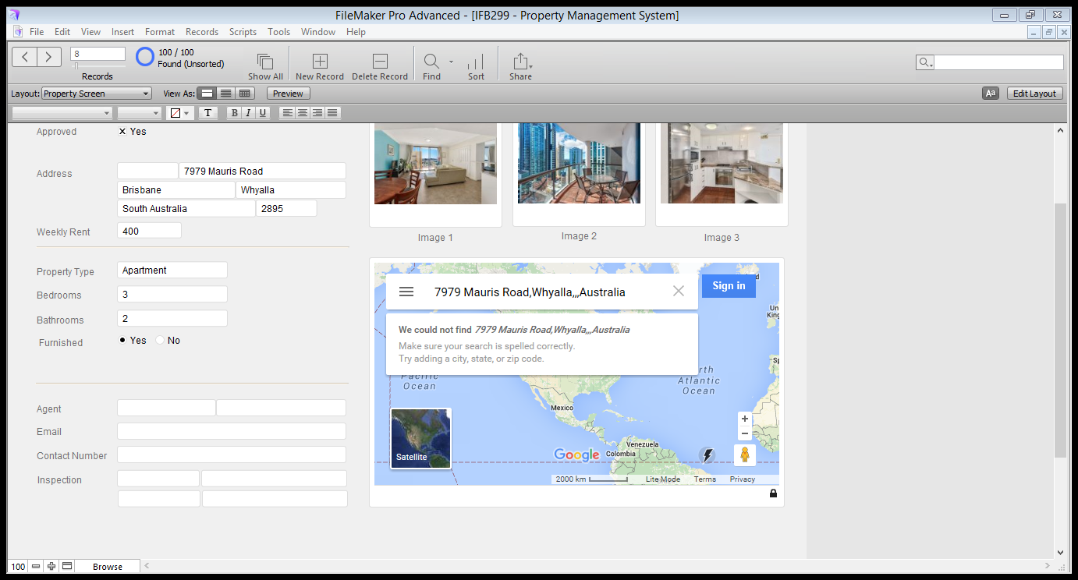  
  
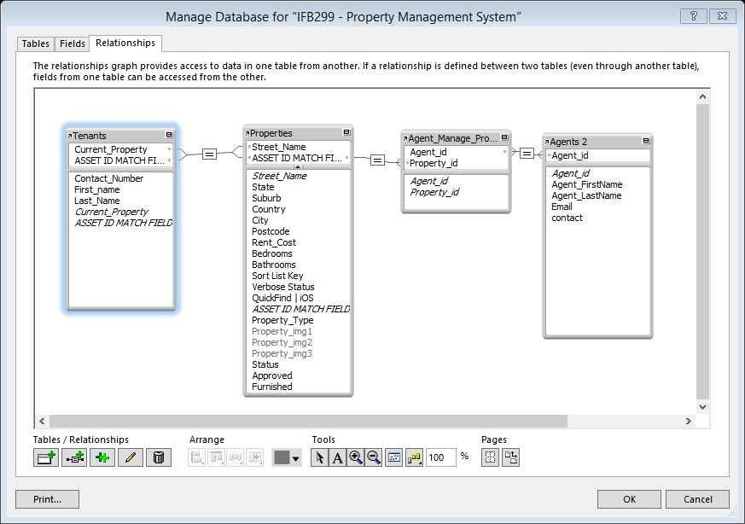

Create tables and its relationships at a preliminary stage so that I can build the user interface in filemaker.

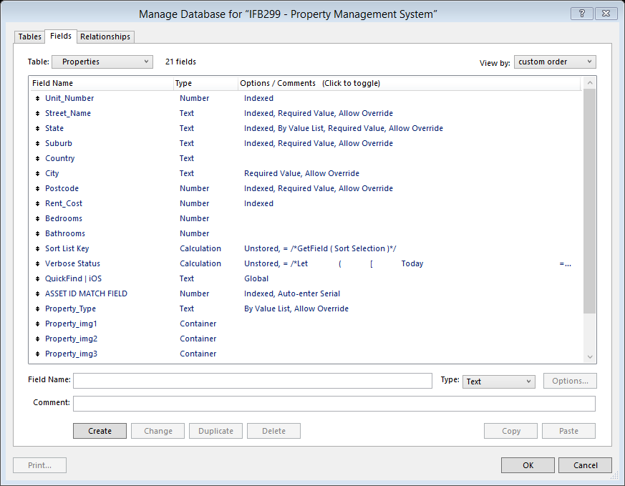

Create table and fields in filmmaker.

Note: For viewing a published version of the webpage, please refer to Cameron’s folder. Because I don’t have access to Filemaker server to produce an output for the tutor.